**WEEK 3**

**Q-1:Write a java program to add the two numbers**

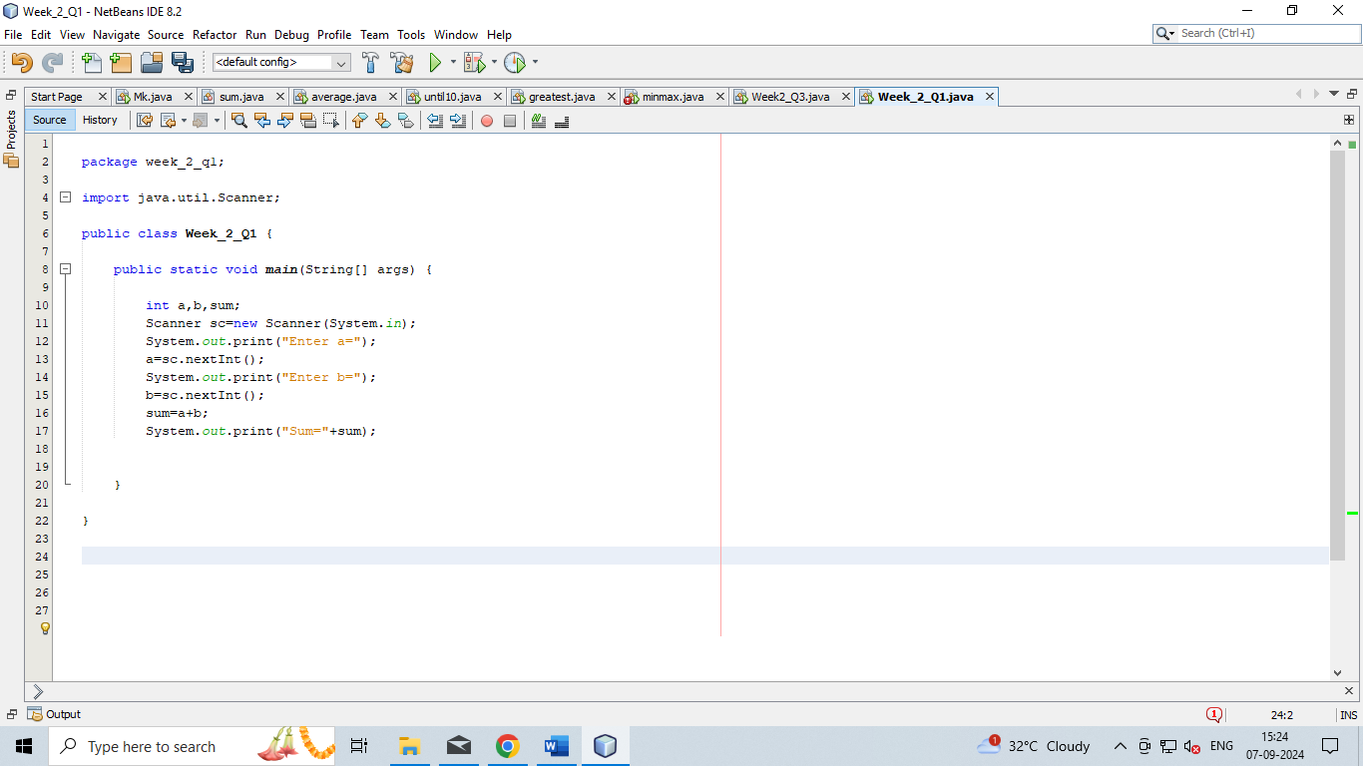

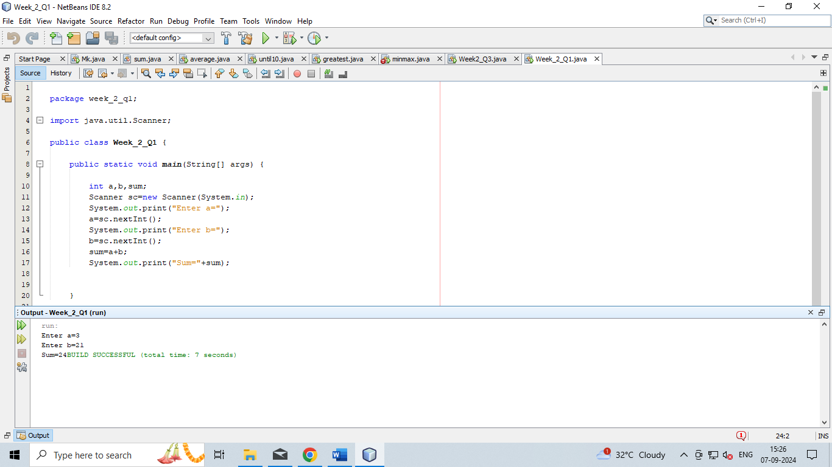

**Q-2:Write a java program to multiply two floating numbers.**

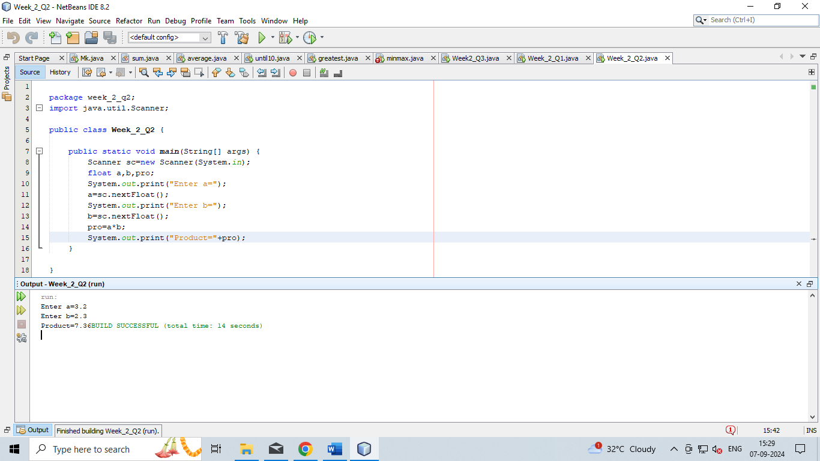

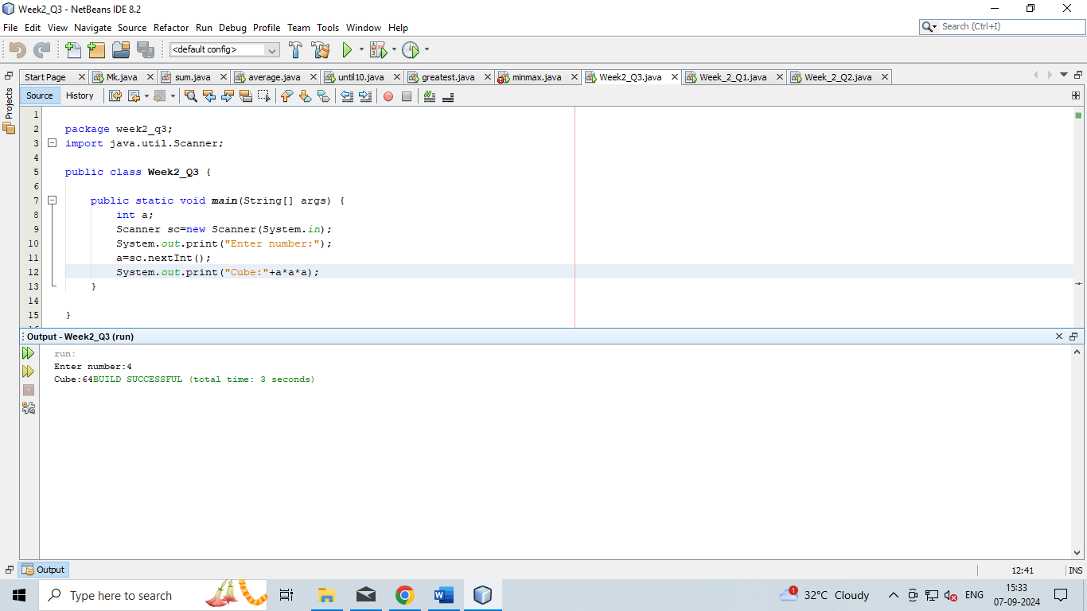**Q-3:Write a java program to display a cube of a number.**

**Q-4:Write a Java program that takes three numbers as input to calculate and print the average of the numbers.**

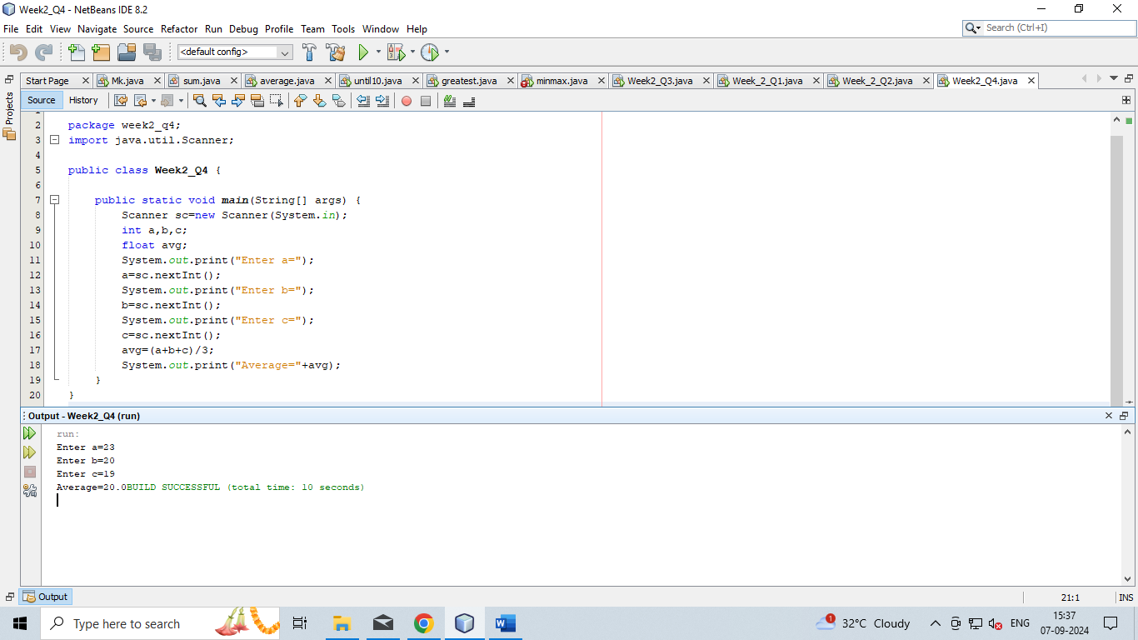

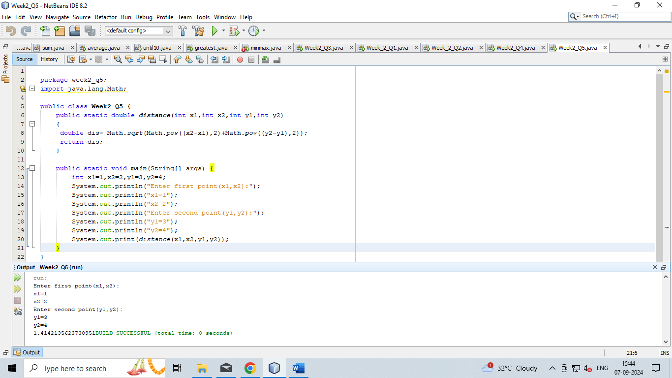**Q-5: Write a Java program to compute the distance between two points**